

press release
(English translation)

TTG 2024: THE 61st EDITION OF THE PREMIER EVENT FOR THE PROMOTION OF WORLD TOURISM KICKS OFF TOMORROW IN RIMINI

- At the opening ceremony, the Minister of Tourism Daniela Santanché, the Vice President of the Senate Gian Marco Centinaio, and a number of institutional and category representatives

- From Wednesday 9 to Friday 11 October, Italian Exhibition Group summons 2,700 exhibiting brands and over 1,000 foreign buyers for TTG Travel Experience and InOut|The Contract Community, the event dedicated to hospitality and indoor and outdoor design

- Italy tourism proudly presents its 20 regions alongside 66 foreign destinations, 11 more than the 2023 edition

- “Veritas” - the main theme both of the edition itself and of the over 200 events, including talks and conferences

ttgexpo.it – inoutexpo.it

Rimini (Italy), 8 October 2024 – The world of tourism gathers in Rimini. Filling the pavilions of Rimini Expo Centre, the 61st edition of TTG Travel Experience organised by Italian Exhibition Group (IEG) will get under way, in conjunction with InOut|The Contract Community, the event dedicated to the entire indoor and outdoor community for tourism.
With 2,700 exhibiting brands, 55 start-ups and over 1,000 foreign buyers from 75 countries, Rimini Expo Centre is all set to host the most extensive Italian tourism offering showcasing its 20 Regions and more than 66 foreign destinations (11 more than the 2023 edition), confirming TTG as the largest national event for the promotion of world tourism.
TTG Travel Experience and InOut|The Contract Community will be officially inaugurated at 12 noon in the Main Arena (South Hall). The opening ceremony, moderated by journalist Claudio Calì, will feature speakers Maurizio Ermeti, President of Italian Exhibition Group, Jamil Sadegholvaad, Mayor of Rimini, Andrea Corsini, Councillor for Tourism of the Emilia-Romagna Region, Pier Ezhaya, President of ASTOI-Confindustria Viaggi, Franco Gattinoni, President of FTO-Federazione Turismo Organizzato, Flavio Ghiringhelli, President of IBAR-Italian Board Airline Representatives, Bernabò Bocca, President of Federalberghi, Federico Pedini Amati, Secretary of State for Tourism of the Republic of San Marino, Gian Marco Centinaio, Vice President of the Senate of the Republic and Daniela Santanchè, Minister for Tourism.

“Veritas” is the main theme of this year’s edition, an explicit forewarning for the tourism industry, which today more than ever needs to rely on truthful stories of the destinations, real trend data and scientifically verifiable market analyses. Gloria Armiri, head of IEG's Travel & Tourism division, explains: “There will be over 200 events organised in the nine arenas of the expo centre with more than 250 industry experts, who over the three days will address the topical issues transversal to the entire tourism industry, from new trends in hospitality, to female leadership in the world of work to social inclusion, from neuroscience for the industry, to the impact of climate change on tourism”. One of the main objectives will be to offer the opportunity to intercept new trends in the industry, explore new tourism formats and provide professionals with tools, ideas and opportunities for discussion to expand their business.
Thanks to the analysis conducted by the Travel Innovation Observatory of the Polytechnic University of Milan, a preview of the data on the travel market in 2024 will be presented the fair, divided into different areas: hospitality, mobility, organised tourism and outdoor experiences. A glimpse into the future will be offered by Travel&Hospitality Vision +25 by TTG, revealing the signals that will guide the choices of the tourism market over the coming three years. Lastly, an important new entry for the InOut|The Contract Community: the ADI InOut Hospitality Design Award, which, in collaboration with ADI - Association for Industrial Design, will be awarded for the first time at the fair to the best projects dedicated to hospitality.

Photo: The magnificent IEG Tourism machine was set in motion today at the Grand Hotel in Rimini with Luxury Event by TTG, the B2B event dedicated to luxury travel

ABOUT: TTG TRAVEL EXPERIENCE
Event: international trade show; organizer: Italian Exhibition Group SpA; recurrence: annual; edition: 61st; open to: reserved exclusively for trade professionals; website: www.ttgexpo.it - #ttgexpo

ABOUT: INOUT | THE CONTRACT COMMUNITY
Event: international trade show; organizer: Italian Exhibition Group SpA; recurrence: annual; edition: 2nd edition of INOUT including SIA, SUN, SUPERFACES, GREENSCAPE; open to: reserved exclusively for trade professionals; website: www.inoutexpo.it #inoutexpo

PRESS CONTACT IEG, TTG TRAVEL EXPERIENCE
Elisabetta Vitali, head of corporate communication & media relations; Marco Forcellini, Pier Francesco Bellini, press office manager - media@iegexpo.it

MEDIA AGENCY TTG TRAVEL EXPERIENCE: Mind The Pop
Martina Vacca: martina@mindthepop.it, mob. +39 339 748 5994; Fabrizio Raimondi: fabrizio@mindthepop.it, mob. +39 335 389 848; Benedetto Colli: benedetto@mindthepop.it, mob. 380 371 2272; Stefano Chiossi: stefano@mindthepop.it, mob. + 39 388 739 4358.

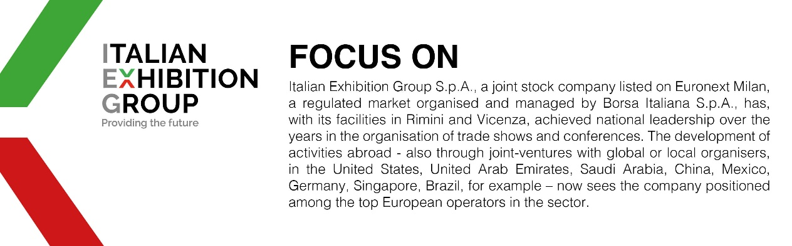

This press release contains forecast elements and estimates that reflect the management’s current opinions (“forward-looking statements”), particularly regarding future management performance, realization of investments, cash flow trends and the evolution of the financial structure. For their very nature, forward-looking statements have a component of risk and uncertainty, as they depend on the occurrence of future events. The effective results may differ (even significantly) from those announced, due to numerous factors, including, only by way of example: food service market and tourist flow trends in Italy, gold and jewellery market trends, green economy market trends; the evolution of raw material prices; general macroeconomic conditions; geopolitical factors and evolutions in the legislative framework. Moreover, the information contained in this release does not claim to be complete, and has not been verified by independent third parties. Forecasts, estimates and objectives contained herein are based on the information available to the Company as at the date of this release.

